The Business of Tesla: Financial Insights & Industry Benchmarking

Contents

Project Background 2

Executive summary 2

Data Collection and Methodology 3

Tesla’s Financial Performance Analysis 3

Revenue Growth and Market Expansion 4

Summary table: 5

Analysis of Tesla's Free Cash Flow (FCF) Trend (2021–2024) 6

Return of Assets 7

Competitive Benchmarking: Tesla & Industry Peers 8

Total Revenue Generated per Company 9

Net Profit Margin per Company 10

Free Cash Flow per Company 12

Debt-to-Equity Trends 13

Recommendations for Tesla: 14

Strategic Recommendations for Tesla (2024 & Beyond) 14

1. Improve Profit Margins Without Over-Reliance on Price Cuts 15

2. Strengthen Competitive Position Against BYD & Other Automakers 15

3. Optimize Cash Flow & Reduce Capital Expenditures (CAPEX) 15

4. Diversify Revenue Streams Beyond Vehicle Sales 16

5. Reduce Debt Reliance While Expanding Profitably 16

6. Improve Stock Performance & Investor Confidence 17

7. Strengthen Tesla’s Market Position in China 17

8. Leverage AI, Robotics, and Future Technologies 17

Final Verdict: Can Tesla Stay Ahead? 18

Conclusion 18

References: 18

# Project Background

Tesla, as the market leader in the rapid growth electric vehicle (EV) industry counters increasing competition from automakers like GM and Ford and EV-focused companies such as BYD, has made the EV market highly competitive. Expanding operations, factors like profitability, cash flow management, and market expansion has become very essential for Tesla to sustain its leadership position in the EV industry.

The main aim of this project is to analyse Tesla’s financial performance in comparison to its industry peers, focusing on key metrics such as revenue, net profit margin, operating income and debt-to-equity ratios. This project will show Tesla’s stock performance, market positioning and operational performance trends to assess its long-term sustainability. The information gathered from this analysis will provide key insights for investors, analysts and people in general who are interested to understand Tesla’s competitive strengths and weaknesses.

# Executive summary

Tesla's dominance in the EV market is being challenged as profitability weakens despite record revenues of $97.69 billion in 2024. As BYD narrows the sales gap, Tesla must shift its strategy to sustain long-term leadership. Tesla's net profit margin fell from 16.98% in 2022 to 7.94% in 2024, reflecting profitability issues. This cut is also synchronized with price reductions Tesla made to its cars which boosted demand but at the expense of unit profitability. Operating income also went down from $13.83 billion in 2022 to $7.55 billion in 2024 on the back of rising production and labour costs.

Free cash flow volatility also highlights the financial distress of Tesla. From a high of $7.9 billion in 2022, FCF declined to $3.6 billion in 2024 during Gigafactory expansions, investments in AI, and supply chain costs. Similarly, return on assets (ROA) also fell from 16.8% in 2022 to 13.59% in 2024, showing Tesla's capital inefficiency despite healthy revenue growth.

Competition is building in the EV market. Tesla is still ahead, but by shipping 1.789 million BEVs in 2024, BYD is catching up with 1.765 million units sold. As Tesla engages in price wars, profitability and market leadership will be the name of the game to maintain. Nevertheless, Tesla's strong debt-to-equity ratio of 0.12 compared to GM's 1.87 and Ford's 3.27 indicates good financial health, which is a source of investor confidence. Tesla must execute strategic cost efficiencies while balancing growth and profitability to solidify its market position in an increasingly competitive EV market.

**Key Recommendations for Tesla:**

* Optimize Gigafactory production through automation and AI-driven manufacturing efficiencies.
* Focus on sales of higher-margin vehicles (Model S, Model X).
* Expand into new markets such as India, leveraging government incentives and growing EV demand.
* Strengthen Supercharger partnerships to drive greater EV adoption and lock in brand loyalty.
* Delay new Gigafactory builds until current ones reach peak efficiency.
* Focus on high-ROI initiatives to drive free cash flow predictability.
* Provide more precise guidance on earnings and improved cost-cutting transparency.
* Align long-term investment plans with profit targets to reassure investors.

# Data Collection and Methodology

Tools Used: Excel, Python, SQL, PowerBi

Sources: YFinance and Ycharts

The financial data of Tesla and its competitors (BYD, Ford, GM) was collected mainly from YFinance to get real-time data. Additional insights were gathered through Tesla’s official financial reports, industry news (like YCharts), and competitor benchmarking.

Tools used:

Excel:

* Excel was used as a complementary tool for financial data organization, preliminary analysis, and visualization before deeper analysis in Python, SQL, and Power BI.

Python was used to extract and analyze financial data for Tesla and its competitors. The following libraries were utilized:

* Pandas: To clean, manipulate, and analyze financial datasets.
* yfinance API: To extract real-time financial data directly from Yahoo Finance.

SQL (For Structuring & Querying Data)

* SQL was used to store, filter, and analyze structured financial datasets efficiently.
* Queries were written to calculate financial ratios, profit margins, and revenue trends for Tesla vs. competitors.
* SQLite was used as the database management system.

Data Processing & Analysis:

* Data Extraction:
  + Python’s yfinance library was used to pull financial statements (cash flow, revenue, expenses).
  + SQL queries were executed to retrieve structured data from financial datasets.
* Data Cleaning & Transformation:
  + Missing values were handled using Pandas.
  + Data types were standardized for consistency (dates, currency formats).
  + Key financial metrics (net profit margin, debt-to-equity ratio, free cash flow) were calculated.
* Data Visualization & Competitive Analysis:
  + Power BI was used to create interactive dashboards visualizing financial trends.

Challenges:

* Data limitations:
  + Some data like BYD’s operating cash flow was not present in YFinance.
* Competitor Comparisons:
  + Different automakers have varying business models (e.g., BYD also sells hybrid vehicles, whereas Tesla is 100% EV-focused).

Raw Code will be in another folder called ‘Tesla Codes’

# Tesla’s Financial Performance Analysis

Tesla’s revenue has grown through the years from 2021 to 2024 however it’s not the same for profit. This is because of increased operating costs, price reductions and increased competition. This section will focus on Tesla’s revenue, profit margins, debt, free cash flow, stock price, return of assets, and operating income.

## Revenue Growth and Market Expansion

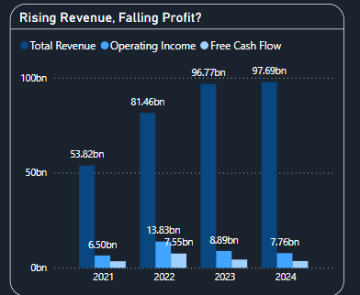

Tesla has experienced great revenue growth throughout the years. However operating income has been falling since it peaked at $13.83 billion in 2022.

Reasons for falling operating income:

* These are some of the Price Cuts Tesla announced on 13th January:
  + Model Y Long Range (One of the best-selling products) cut down 24.53% from $65,990 to $52,990.
  + 4680 Model Y Standard Range AWD from $63,990 to $50,990 a decrease of 25.49% which is $13,000 cheaper.
  + For model 3 the vehicle’s base RWD the price went from $46,990 to $43,990 a total of $3,000 decrease of 6.82% in price.
  + Price cut increased Tesla’s demand and put pressure on other companies like Ford and GM to lower down their prices, but this still led to a decrease in overall profit for Tesla.
* Rising Production Costs:
  + Tesla expanded its workforce andincreased wages in some regions. Hiring skilled labour for AI, software development, and manufacturing has increased Tesla’s expenses.
  + Gigafactory Expansion requires a high up-front cost even though they will be a good long-term investment as they improve their efficiency.
  + Global supply chain disruptions have caused delays and increased transportation costs.
* Increased Competition:
  + Tesla is no longer dominating in this sector. BYD is very close. In 2024, BYD sold 1.765 million BEVs, not far behind to Tesla’s 1.789 million.
  + Tesla’s BEV market share is decreasing as competition rising.

### Summary table:

|  |  |  |
| --- | --- | --- |
| Factors | Impact on Tesla | Financial Effect |
| Price Cuts | More sales, but lower profits per product sold | Decrease in net profit margin since 2022 (16.98%) to 2024 (7.94%) |
| Rising Production Costs | Labour and factory costs | Decrease in gross profit margin throughout the years since 2022 (25.60%) to 2024 (17.86%) |
| Increased Competition | Can no longer fully control the EV industry like it used to | Tesla’s market share shrinking, making it harder to maintain high profits |

## Analysis of Tesla's Free Cash Flow (FCF) Trend (2021–2024)

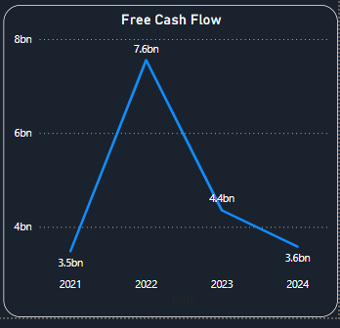

This graph illustrates Tesla’s Free Cash Flow (FCF) from 2021 to 2024, showing significant fluctuations.

Observations:

* Steady Increase (2021–2022):
  + Due to high demand and sales for Tesla’s cars
  + Higher profit margin which was at nearly 17% in 2022
  + Operational efficiency improvements in Gigafactories
* Sharp Decline (2022–2023) 42% decrease could be due to:
  + Aggressive EV price cuts, reducing profit per vehicle.
  + Increased production costs (like labour costs).
  + Higher capital expenditures (CAPEX) due to Gigafactory expansions.
* Continued Decline (2023–2024):
  + More investments in AI, self-driving technology, and manufacturing expansion.
  + Price wars with competitors (BYD, GM, Ford), reducing per-unit profits.
  + Supply chain expenses affecting Tesla’s cash reserves.

## A screenshot of a phone AI-generated content may be incorrect.A screenshot of a phone AI-generated content may be incorrect.A screenshot of a phone AI-generated content may be incorrect.A screenshot of a phone AI-generated content may be incorrect.Return of Assets

Return on assets (ROA) is a financial ratio that indicates how profitable a company is relative to its total assets.

* ROA increased from 2021 (10.46%) to 2022 (16.80%):
  + Tesla experienced record profits in 2022 due to strong demand, high vehicle prices, and efficient production.
  + The company's Net Profit Margin was 16.98% in 2022, meaning Tesla was generating more income from each dollar of revenue.
  + Tesla expanded production at Gigafactories in Berlin and Texas, increasing vehicle output. This meant better use of factory assets, leading to higher asset efficiency.
  + A higher ROA in 2022 showed that Tesla was generating more profits per dollar of assets, indicating efficient asset utilization.
* ROA declined from 2022 (16.80%) to 2024 (15.41%):
  + Tesla started cutting EV prices in 2023, reducing per-vehicle profit. The net profit margin dropped from 16.98% in 2022 to 9.19% in 2023.
  + Tesla had to spend more on energy, raw materials, and labour as global inflation impacted costs.
* ROA Declined Further from 15.41% (2023) to 13.59% (2024):
  + Tesla’s capital spending on self-driving AI, battery technology, and energy storage systems increased which decreased its free cash flow.
  + Tesla further reduced EV prices to stay competitive against BYD, GM, and Ford.
  + High fixed costs (factories, R&D, marketing) meant that even with revenue growth, profit per asset was declining.

# Competitive Benchmarking: Tesla & Industry Peers

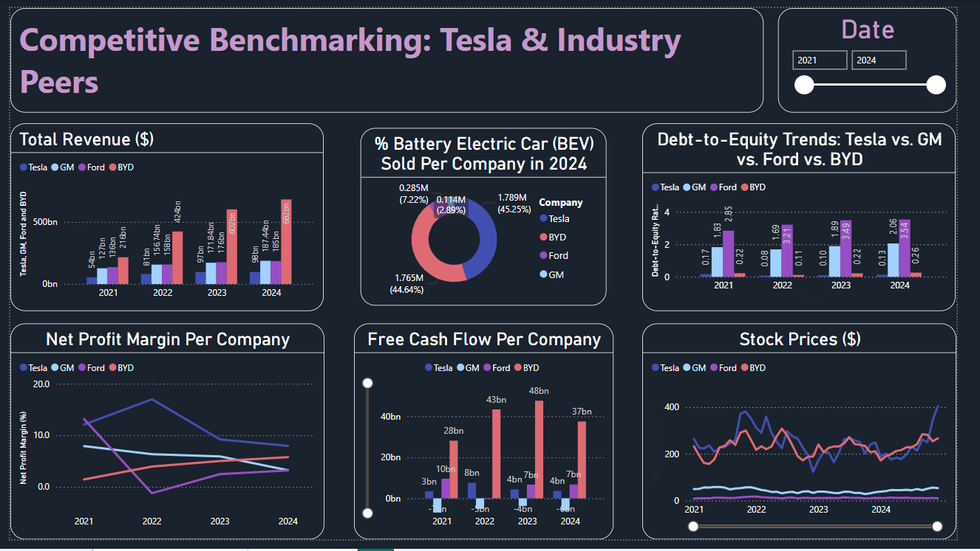

This Power BI dashboard provides a comparative analysis of Tesla’s financial performance against key competitors: BYD, GM and Ford from 2021 to 2024. It focuses on total revenue, net profit margins, battery electric vehicles (BEV) sales, free cash flow, stock prices and debt-to-equity ratios to see how well Tesla is doing compared to its industry peers

## Total Revenue Generated per Company

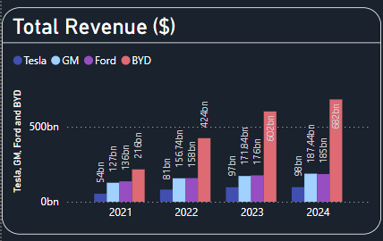

BYD’s Explosive Growth – Surpassing Tesla, GM, and Ford:

* BYD’s revenue surged from $216 billion in 2021 to $682 billion in 2024 a 216% increase in just three years.
* BYD now has 7x Tesla’s revenue in 2024

Why this happened?

BYD’s stronghold is China which is the world's largest EV market. Tesla faces competition in China, whereas BYD has home-field advantage and strong government support.

BYD manufactures its own batteries, reducing supply chain costs. Lower production costs mean cheaper EVs which therefore leads to a higher demand.

Since BYD offers more affordable models, making EVs accessible to mass-market consumers.

Ford & GM’s Steady Growth but Slower EV Adoption:

* Ford’s revenue grew from $136B (2021) to $185B (2024).
* GM’s revenue increased from $127B (2021) to $187.44B (2024).

Why did this happen?

Currently Ford and GM still rely on internal combustion engines (ICE) vehicle sales. Unlike Tesla and BYD, EV revenue for them is only a fraction of their total business, limiting overall growth.

Ford and GM face higher production costs for EVs than Tesla and BYD due to battery supply constraints. GM & Ford are strong in the U.S., but EV adoption has been slower than in China/Europe which has affected their EV sales and are not growing fast enough to match the growth of Tesla and BYD.

## Net Profit Margin per Company

BYD’s Gradual Increase in Profitability:

* BYD’s net profit margin was lowest in 2021 but gradually increased in 2024 while Tesla’s net profit margin has been decreasing since 2022.

Why did this happen?

One of the main reasons is that BYD produces its own batteries, which therefore reduces supply chain costs. So, production cost is lower.

BYD increased exports to Europe, Latin America, and Southeast Asia, raising profitability. Unlike Tesla, BYD’s focus on hybrid EVs (PHEVs) helped sustain revenue while expanding full EV sales.

China provides strong subsidies for domestic EV makers, reducing costs for BYD. Tesla, being a foreign company, does not receive the same level of government backing.

GM & Ford’s declining Profit Margins:

* Both companies had a decline in profit margins from 2021 to 2024. In 2022 Ford experienced the lowest dip before recovering slightly in 2023 and 2024.

Why did this happen?

The EV divisions for both companies are not yet profitable which lowers the overall profit margins.

Battery supply chain issues increased costs for GM & Ford and so did having higher labour & operational costs which reduced efficiency.

They also sell less volume meaning lower economies of scale which leads to lower profit margins.

|  |  |  |
| --- | --- | --- |
| Company | 2024 Net Profit Margin Trend | Key Reasons for Change |
| Tesla | Declined | Price cuts, higher costs, increased competition |
| BYD | Increased | Lower Costs, strong China sales and government support |
| Ford | Declined, then slightly recovered | High EV costs, supply chain issues, ICE Vehicle decline |
| GM | Declined | EV struggles, higher production costs, legacy expenses |

## Free Cash Flow per Company

BYD has the highest Free Cash Flow in the last four years:

* BYD’s Free Cash Flow surged from $28 billion in 2021 to $48 Billion in 2023 before slightly declining to $37 billion in 2024.
* It far exceeds Tesla, GM and Ford’s cash flow, indicating strong financial stability and operational efficiencies.

Ford’s Free cash flow is volatile:

* Ford had a very strong FCF of $18B in 2021 however in 2022, Ford’s FCF dropped drastically to -$1.3M. Ford did recover back in 2023 and 2024.

GM Has Consistently Negative Free Cash Flow:

* GM’s FCF has been negative every year, reaching -$5B in 2022 and -$4B in 2023–2024. Reasons like Battery production delays, labour strikes, and supply chain costs have hurt GM’s cash flow.

## Debt-to-Equity Trends

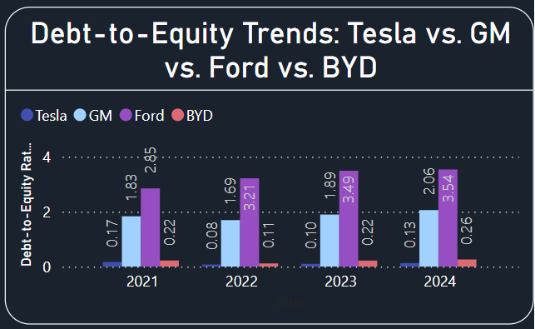

Debt-to-Equity Ratio (D/E) measures how much debt a company uses relative to its shareholder equity.

* A higher ratio (>1) means the company relies more on debt to finance its operations, which increases financial risk.
* A lower ratio (<1) means the company is less reliant on debt and finances growth through equity and retained earnings.

Tesla Has the Lowest Debt-to-Equity Ratio (Financially Conservative):

* Tesla’s D/E ratio remained low, ranging from 0.17 in 2021 to 0.13 in 2024.
* Tesla avoids heavy reliance on debt and funds expansion using retained earnings and stock sales.

Why did this happen?

* Tesla’s strong profit margins (until 2022) allowed it to expand without borrowing heavily.
* Tesla has raised capital through stock offerings, reducing the need for loans.
* With a strong market presence, Tesla attracts investors, allowing it to expand without debt burdens.
* Tesla has paid down debt over the years, ensuring a low-risk financial structure. (Debt Reduction Strategy)

GM & Ford Have High Debt-to-Equity Ratios (Heavily Leveraged)

* GM’s D/E ratio increased from 1.83 (2021) to 2.06 (2024).
* Ford’s D/E ratio remained very high, rising from 2.85 (2021) to 3.54 (2024).

Why did This happen?

* Unlike Tesla, they rely heavily on loans and bonds to finance new EV factories, R&D, and battery production.
* Tesla & BYD’s EVs are profitable, but GM & Ford’s EV divisions are still struggling to break even. GM & Ford rely on loans to sustain EV expansion while waiting for profitability.

BYD’s Debt is Increasing but Still Lower Than GM & Ford

* BYD’s D/E ratio rose from 0.22 (2021) to 0.26 (2024) but remains much lower than Ford & GM.

Why did this happen?

* BYD is investing heavily in battery production, global expansion, and new EV models, requiring some debt financing.
* BYD receives subsidies & favourable loan conditions from the Chinese government, reducing borrowing costs.

# Recommendations for Tesla:

## Strategic Recommendations for Tesla (2024 & Beyond)

Tesla faces increasing competition, declining profit margins, and challenges in sustaining strong free cash flow. To maintain its leadership position in the EV industry, Tesla must optimize operations, improve financial efficiency, and diversify revenue streams. Below are the key strategic recommendations for Tesla moving forward:

## 1. Improve Profit Margins Without Over-Reliance on Price Cuts

Tesla’s net profit margin has declined due to frequent price reductions on EV models, impacting revenue per vehicle.

**Recommendations:**

* Optimize production costs by increasing Gigafactory automation and improving supply chain efficiency.
* Focus on higher-margin models (Cybertruck, Model S/X) to offset lower-margin EVs.
* Monetize Full-Self Driving (FSD) subscriptions and software upgrades for recurring revenue.
* Reduce battery production costs through in-house advancements and new supplier agreements.

Expected Outcome: Tesla can maintain profitability while keeping its competitive pricing strategy.

## 2. Strengthen Competitive Position Against BYD & Other Automakers

BYD has surpassed Tesla in revenue and is catching up in BEV sales, especially in China.

**Recommendations:**

* Expand into emerging markets such as India, Southeast Asia, and Latin America where EV adoption is rising.
* Improve Tesla’s Supercharger network and license access to other automakers to create an additional revenue stream.
* Develop affordable Tesla models ($25,000 segment) to compete with BYD’s lower-cost EVs.

Expected Outcome: Tesla secures market share in developing economies and maintains its global dominance.

## 3. Optimize Cash Flow & Reduce Capital Expenditures (CAPEX)

Tesla’s free cash flow growth has slowed due to significant Gigafactory expansion costs.

Recommendations:

* Improve existing Gigafactory efficiency before opening new production facilities.
* Scale down non-critical R&D projects while focusing on core vehicle & battery advancements.
* Reduce supply chain inefficiencies to minimize working capital constraints.

Expected Outcome: Tesla maintains positive free cash flow while still investing in future growth.

## 4. Diversify Revenue Streams Beyond Vehicle Sales

Tesla relies heavily on EV sales, making its profitability vulnerable to price cuts and market fluctuations.

Recommendations:

* Expand Tesla Energy (solar, Powerwall, Megapack) to capture more of the renewable energy market.
* Increase FSD subscriptions and enhance self-driving technology for a more attractive consumer package.
* License Tesla’s AI, battery tech, and energy solutions to other companies for additional revenue.

Expected Outcome: Tesla reduces its reliance on vehicle sales and creates more stable, recurring revenue streams.

## 5. Reduce Debt Reliance While Expanding Profitably

While Tesla has low debt, future expansion could require financing. GM & Ford are heavily leveraged, creating potential financial risks.

Recommendations:

* Continue using equity-based funding and retained earnings to avoid unnecessary debt.
* Focus on cost-effective expansion, prioritizing factories with shorter return-on-investment (ROI) periods.
* Leverage government incentives & tax credits in new markets to reduce capital burden.

Expected Outcome: Tesla remains financially strong without increasing debt risks.

## 6. Improve Stock Performance & Investor Confidence

Tesla’s stock price is volatile, influenced by profitability concerns and increasing competition.

Recommendations:

* Provide clear financial guidance on how Tesla will maintain profitability amid price cuts.
* Offer dividends or stock buybacks to increase shareholder value in the long term.
* Increase transparency on R&D investments to assure investors Tesla remains an innovation leader.

Expected Outcome: A more stable and attractive Tesla stock with strong investor confidence.

## 7. Strengthen Tesla’s Market Position in China

China is the world’s largest EV market, and BYD dominates the region.

Recommendations:

* Partner with Chinese tech & energy firms to strengthen Tesla’s brand and reach.
* Expand local production in China to reduce import tariffs and stay competitive.
* Develop China-exclusive Tesla models tailored to consumer preferences in the region.

Expected Outcome: Tesla retains a strong presence in China despite growing local competition.

## 8. Leverage AI, Robotics, and Future Technologies

Tesla’s long-term innovation strategy includes AI, robotics, and automation.

Recommendations:

* Accelerate the launch of Tesla Bot (Optimus) for industrial applications.
* Improve AI-driven manufacturing processes to lower production costs.
* Expand robotaxi network and Tesla’s self-driving car initiatives to diversify business offerings.

Expected Outcome: Tesla stays ahead in AI and automation, leading the future of mobility and robotics.

## Final Verdict: Can Tesla Stay Ahead?

Tesla remains the EV leader, but profit margins, competition, and pricing pressures must be addressed. Tesla must diversify beyond cars (Energy, AI, software) to maintain long-term dominance. Tesla is financially stable, but it must balance expansion with profitability to sustain growth.

If Tesla executes these strategies successfully, it will not only defend its market position but also shape the future of transportation, energy, and AI.

# Conclusion

Tesla remains at the forefront of the EV industry, driven by innovation, brand strength, and a commitment to sustainability. However, increasing competition from BYD, declining profit margins, and operational challenges highlight the need for strategic adjustments. While Tesla has maintained financial stability with a low debt-to-equity ratio and positive free cash flow, aggressive price cuts and high capital expenditures have put pressure on profitability.

To sustain its leadership position, Tesla must optimize production efficiency, expand into emerging markets, and diversify revenue streams beyond vehicle sales. Strengthening Tesla Energy, increasing Full-Self Driving (FSD) adoption, and leveraging AI-driven innovations will be crucial to ensuring long-term financial stability. Additionally, Tesla must balance expansion with profitability, reducing unnecessary expenditures while maintaining its position as a technological leader in the automotive and energy industries.

If Tesla successfully implements these strategies, it will not only maintain its competitive advantage but also redefine the future of mobility, artificial intelligence, and renewable energy. By focusing on cost efficiency, market expansion, and technological advancements, Tesla can continue shaping the global EV market and beyond.

References:

1. Yahoo Finance. (n.d.). *BYD Company Limited (BYDDF) cash flow statement*. Yahoo! Finance. Retrieved February 23, 2025, from <https://nz.finance.yahoo.com/quote/BYDDF/cash-flow/>
2. Yahoo Finance. (n.d.). *Tesla, Inc. (TSLA) cash flow statement*. Yahoo! Finance. Retrieved February 23, 2025, from <https://finance.yahoo.com/quote/TSLA/cash-flow/>
3. Yahoo Finance. (n.d.). *Ford Motor Company (F) cash flow statement*. Yahoo! Finance. Retrieved February 23, 2025, from <https://nz.finance.yahoo.com/quote/F/cash-flow/>
4. Yahoo Finance. (n.d.). *General Motors Company (GM) cash flow statement*. Yahoo! Finance. Retrieved February 23, 2025, from <https://nz.finance.yahoo.com/quote/GM/cash-flow/>
5. Hertz, M., & Gokhale, S. (2023, January 13). *Tesla cuts prices of electric vehicles in U.S. market*. Reuters. Retrieved February 23, 2025, from <https://www.reuters.com/business/autos-transportation/tesla-cuts-prices-electric-vehicles-us-market-2023-01-13/>
6. Merano, M. (2023, January 12). *Breaking: Tesla reduces Model 3 and Model Y prices in the United States*. Teslarati. Retrieved February 23, 2025, from <https://www.teslarati.com/tesla-model-3-model-y-price-cut-united-states-update/>
7. Rapier, G., & Naughton, N. (2024, July 11). *Tesla Gigafactories: A look at the manufacturing hubs and their future*. Business Insider. Retrieved February 23, 2025, from <https://www.businessinsider.com/tesla-gigafactory>
8. Tesla. (n.d.). *Giga Texas*. Tesla. Retrieved February 23, 2025, from <https://www.tesla.com/en_nz/giga-texas>
9. Statista. (2024, February). *Ford: Wholesale vehicle sales 2024*. Statista. Retrieved February 23, 2025, from <https://www.statista.com/statistics/297315/ford-vehicle-sales/>
10. Lawrence, E. D. (2025, January 3). *GM's U.S. sales rise 4% in 2024, led by strong demand for pickups and SUVs*. Detroit Free Press. Retrieved February 23, 2025, from <https://www.freep.com/story/money/cars/general-motors/2025/01/03/gm-general-motors-2024-us-sales/77353052007/>
11. Masiero, G., Ogasavara, M. H., Jussani, A. C., & Risso, M. L. (2016). *Electric vehicles in China: BYD strategies and government subsidies*. Revista de Administração e Inovação, 13(1), 3–11. <https://www.elsevier.es/es-revista-revista-administracao-e-inovacao-239-articulo-electric-vehicles-in-china-byd-S1809203916300018>